# **AWS :**

# 

# **AWS Systems Manager - Session Manager & Run Command**

Step 1 : login to aws console and navigate to ec2 dashboard.

Step 2 : create a linux ec2 instance with default configurations.

Step 3: create an IAM role having a policy : “AmazonSSMManagedInstanceCore”.

Step 4: Attach that IAM role with your ec2 instance.

Step 5: now ,navigate to System manager ,search in the search bar with the same keywords and click on that.

Step 6: Now click on the “session manager”.

Step 7: click on ‘start the session”.

Step 8: select your “ec2 instance” in target resource.and click on start session.

Step 9: now run the following command to analyze the session:

sudo su -

ifconfig

uptime

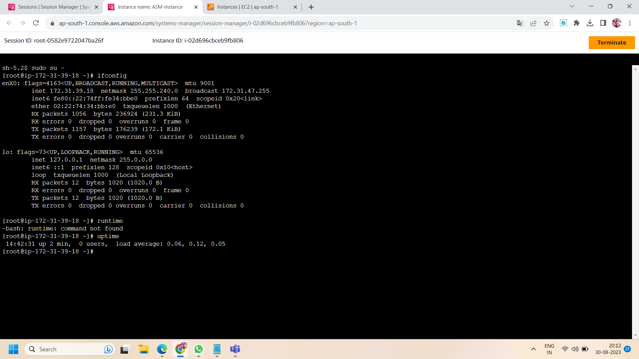

Step 10 : Now check whether the system manager package is installed in the session or not.as usually,by default it is already installed in your session but if not ,you can download by going through the documentation. To check the system manager installation run the following command :

amazon-ssm-agent status

**Run command**

Step 11: Now we want to run the command in the session manager.for this ,go to “run command” in system manager and click on that.

Step 12: After click on run command ,click on “AWS RunShellScript” and type your command in “command parameters” e.g., i want to install httpd so i run the following command:

sudo yum install httpd -y

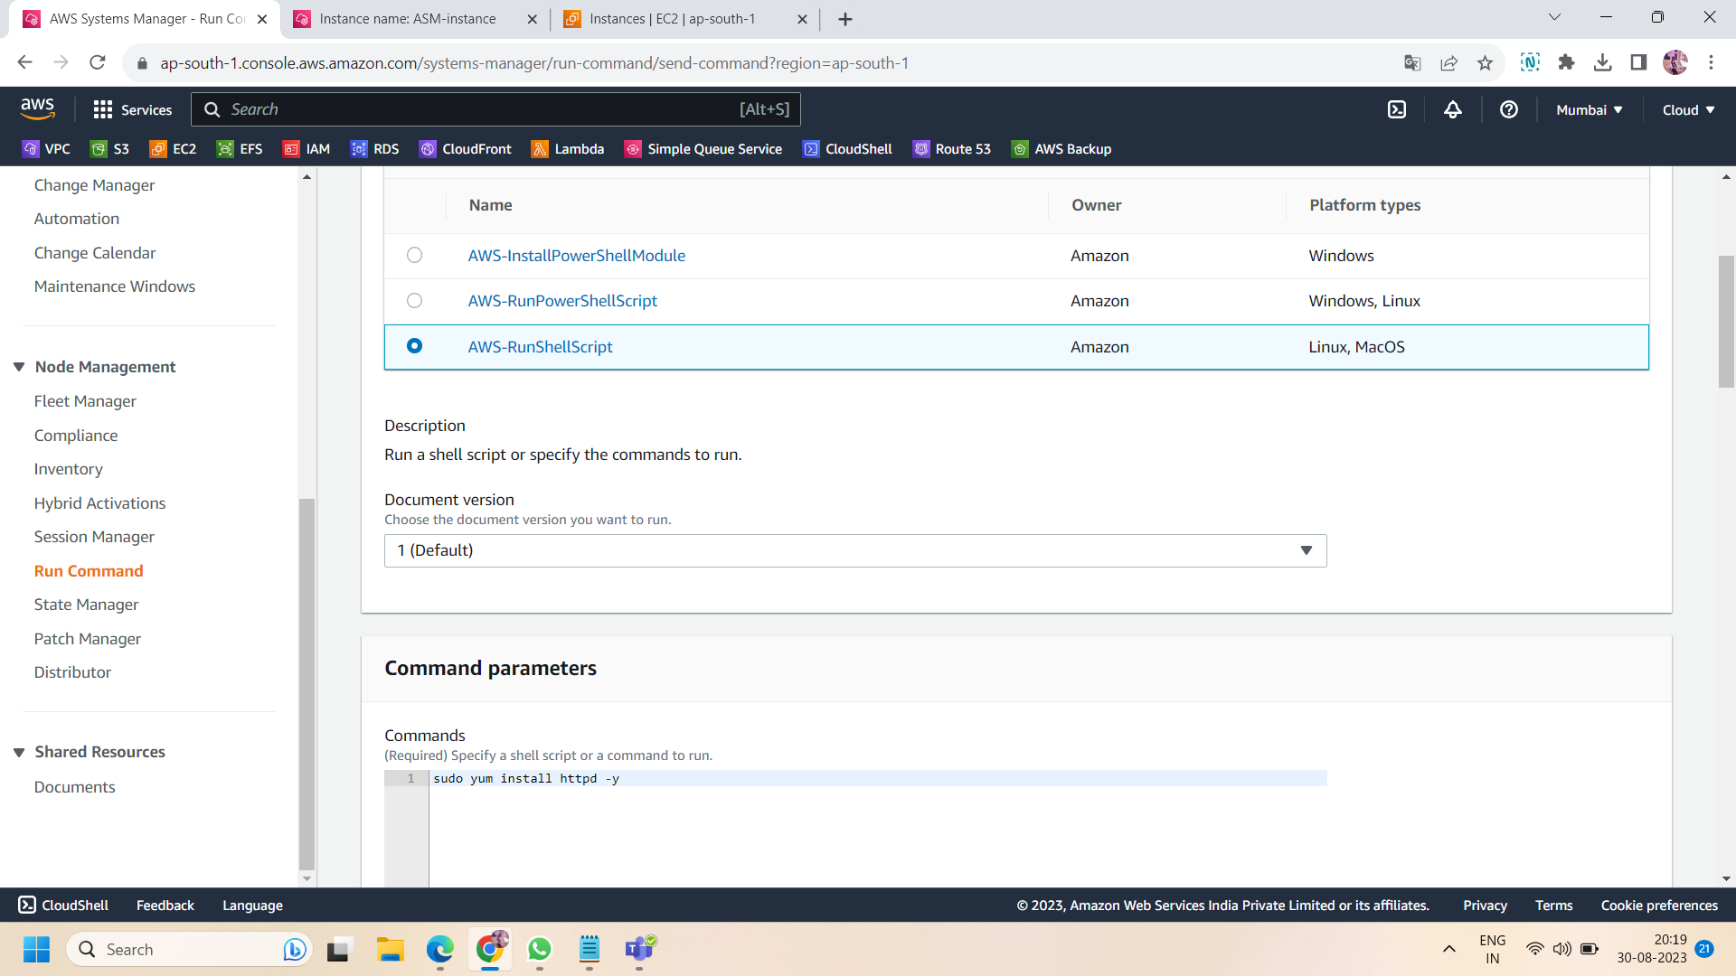

Step 13: After writing the command ,select the “target selection” as “choose instances manually” and then select your ec2 instance.and leave all the settings default and then click on “run command”.

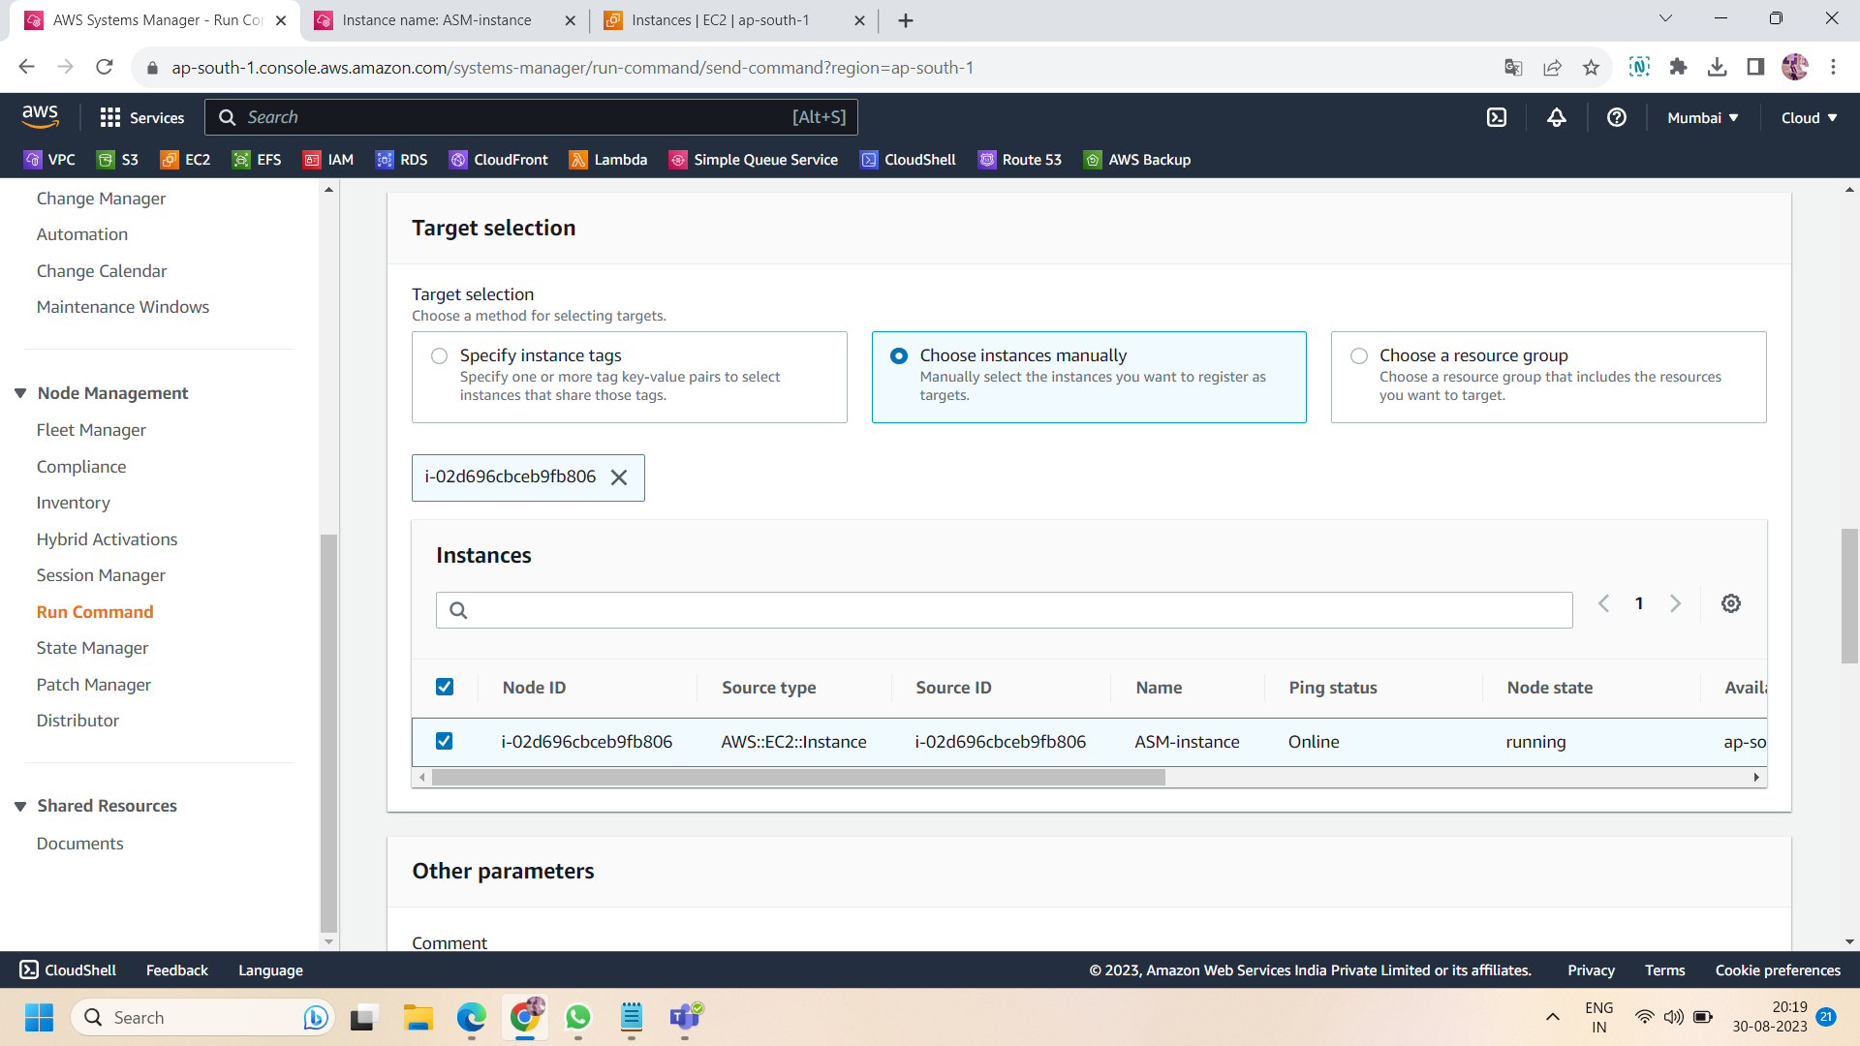

Step 14: now move to session and then check httpd is installed or not by following command:

rpm -qa l grep httpd

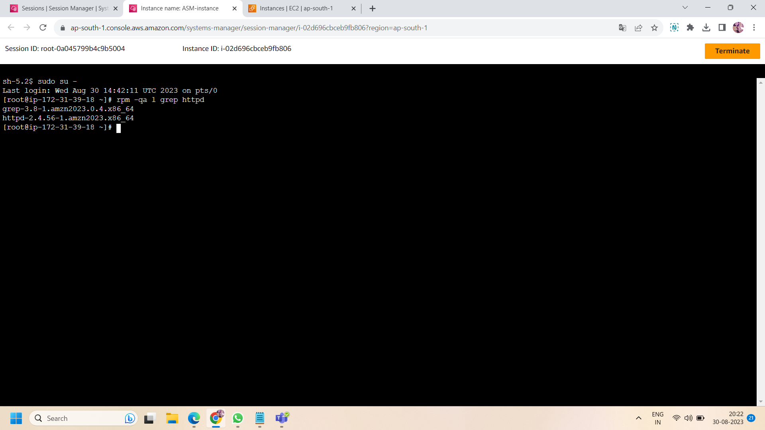

Step 15: if above command ,give you some error then make sure ,you properly run the command .